Windows Server Core Infrastructure Administration
Area of Focus Window Server / Active Directory / Network Infrastructure

📌 Project Overview
This project demonstrates hands-on Windows Server 2022 systems administration in a VMware lab environment. The project is designed around common responsibilities found in an IT Systems Administrator role, including server assessment, core infrastructure services, networking, Active Directory, DNS, DHCP, file services, security and patching, PowerShell administration, monitoring, troubleshooting, and technical documentation.
The objective is to build and validate a stable Windows Server environment while documenting each major administrative action, the reason for the change, verification evidence, and any troubleshooting performed.

🧠 Key Skills Demonstrated
- Windows Server 2022 administration
- IPv4 and Windows network configuration
- Active Directory Domain Services (AD DS)
- DNS and DHCP administration
- Windows file server and NTFS/share permissions
- Windows Firewall and patch-management verification
- PowerShell administration and basic automation
- System monitoring and service
- VMware virtualization
- Technical documentation and change validation

🛠️ Environments & Technologies Used
- VMware Workstation Pro
- Windows Server 2022
- Log N Pacific Server VM
- Windows PowerShell
- Server Manager
- Active Directory Domain Services (AD DS)
- DNS Server
- DHCP Server
- File and Storage Services
- Windows Defender Firewall
- Windows Update
- Event Viewer
💻 Operating Systems
- Windows Server 2022 (Domain Controller)

✅ Tasks Performed
- Documented the existing Windows Server configuration before making changes
- Validated server identity, operating system, hardware resources, and installed roles
- Assessed IPv4, gateway, DNS, DHCP, and network connectivity
- Configured or validated Active Directory and DNS services
- Configured or validated DHCP services and address allocation
- Created and secured a Windows file share using group-based permissions
- Reviewed Windows Firewall and server update status
- Used PowerShell for administration, verification, and basic automation
- Reviewed server health, services, logs, and performance indicators
- Completed a Tier 2 break/fix troubleshooting scenario
- Performed final validation and documented project results

🔄 Project Workflow
- Baseline and change assessment
- Server and network configuration
- Active Directory and DNS
- DHCP administration
- File server and permissions
- Security and patch management
- PowerShell administration and automation
- Monitoring and availability checks
- Tier 2 troubleshooting / break-fix
- Final validation and documentation
This workflow mirrors real-world help desk procedures and emphasizes security and accountability.

📸 Screenshots & Explanations
Existing Server Network Configuration
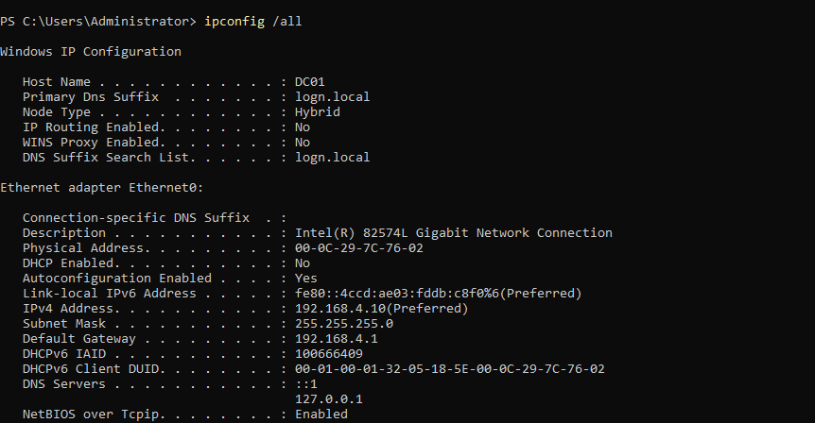
Existing Windows Server Roles
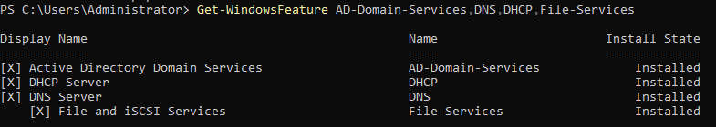
Static Network Configuration
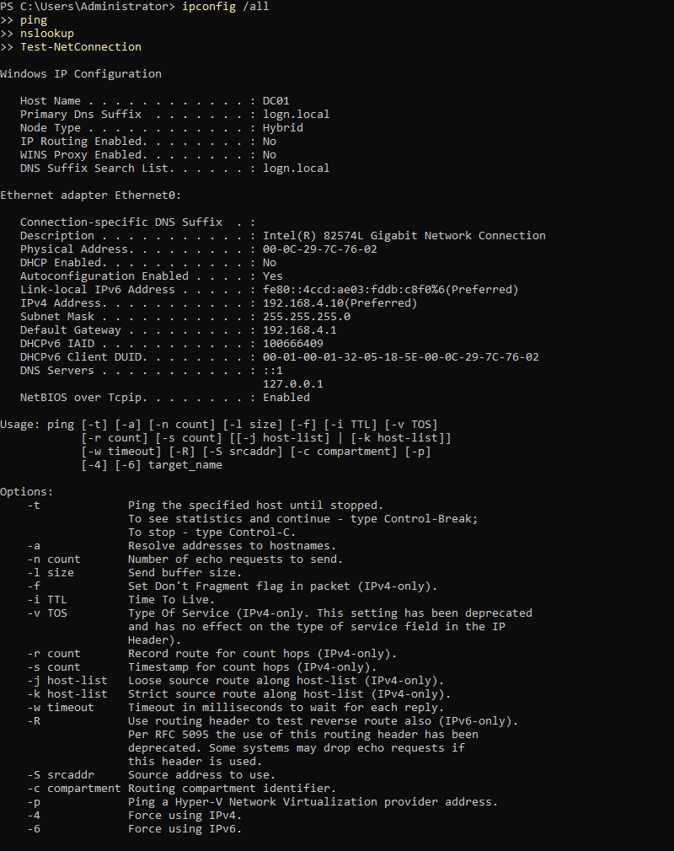

Active Directory Users and Computer – OU Structure
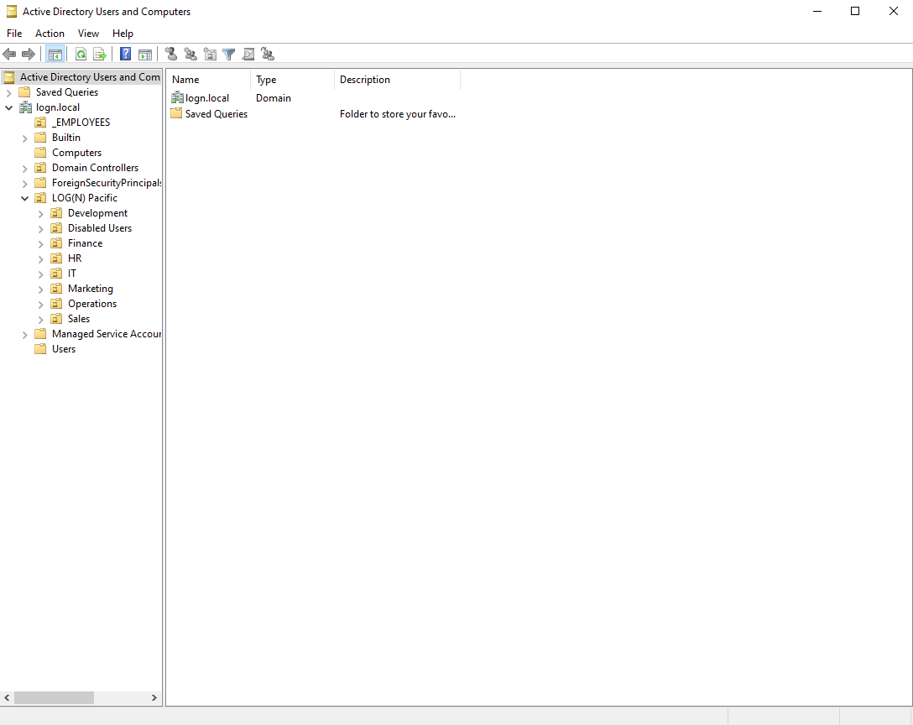
DNS Records
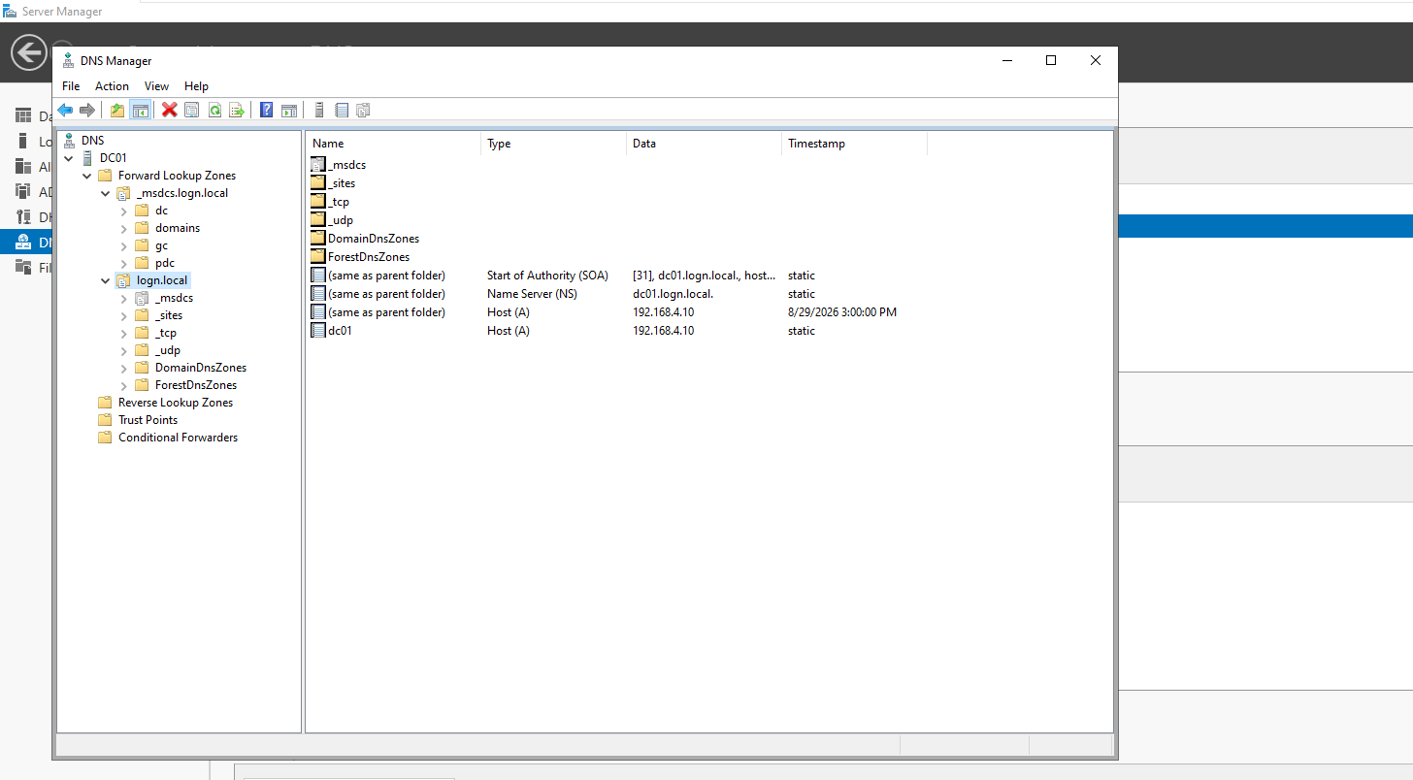

Active Directory Users and Groups
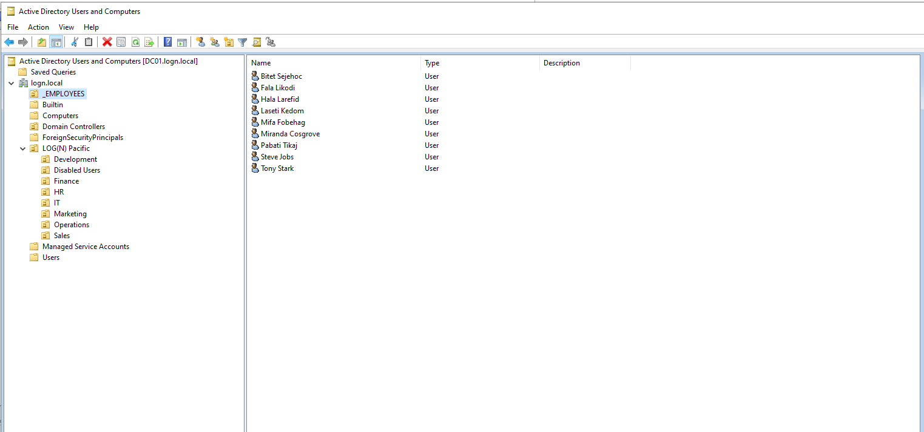
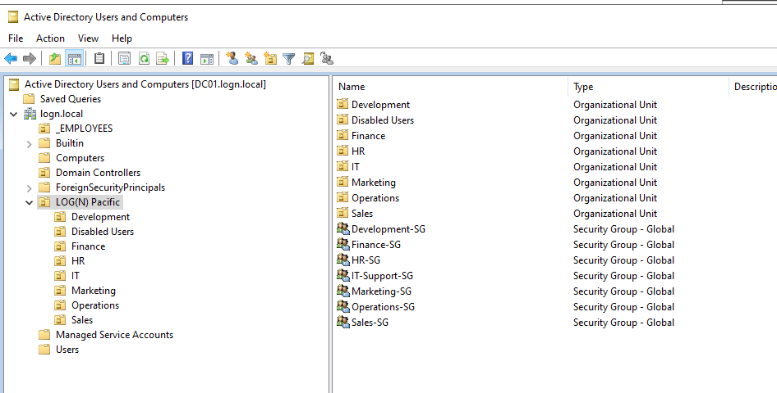

DHCP Scope
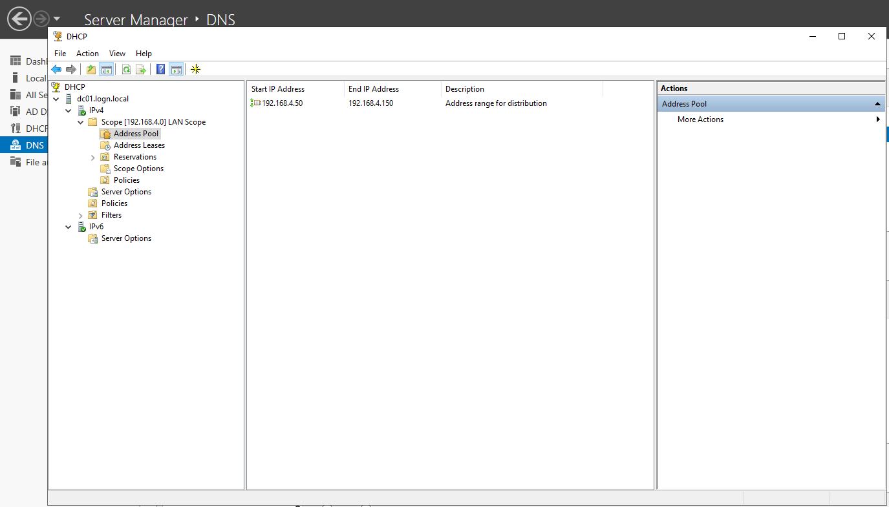

Company Data – Folders
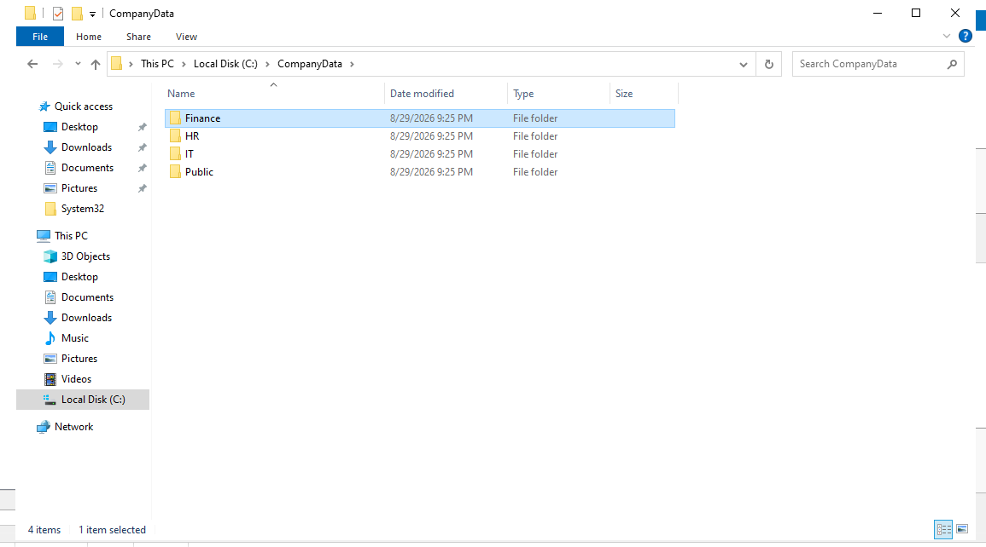

Security & Patch Management
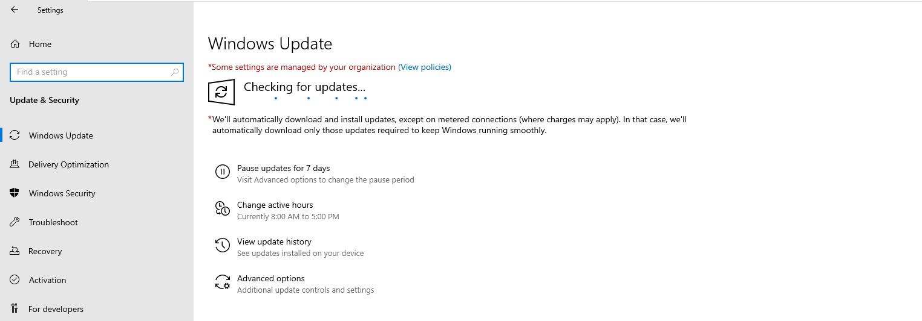
PowerShell Server Health Automation
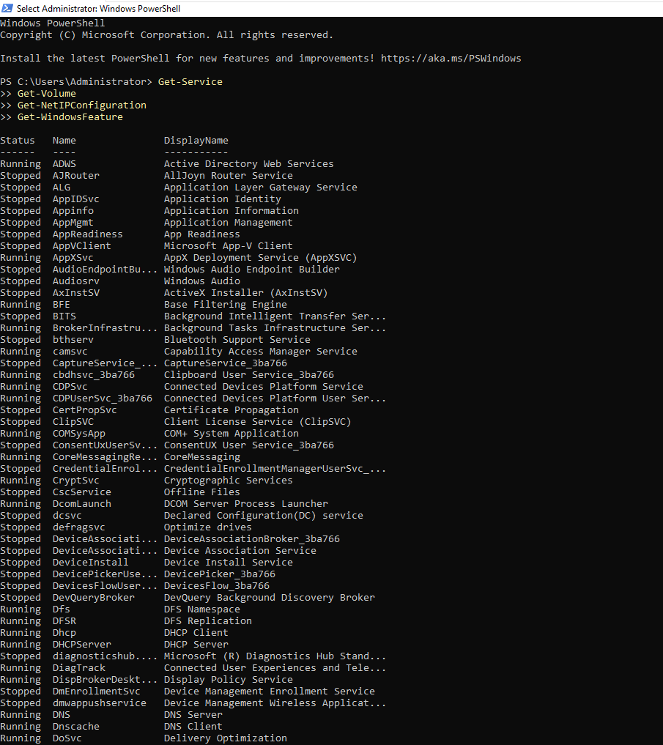
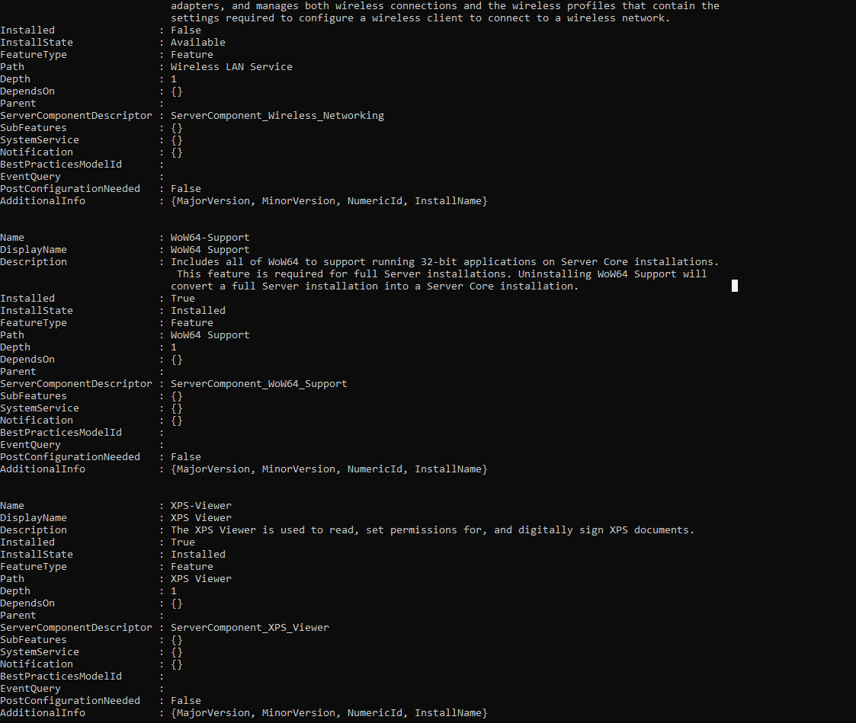

Windows Server Health Monitoring
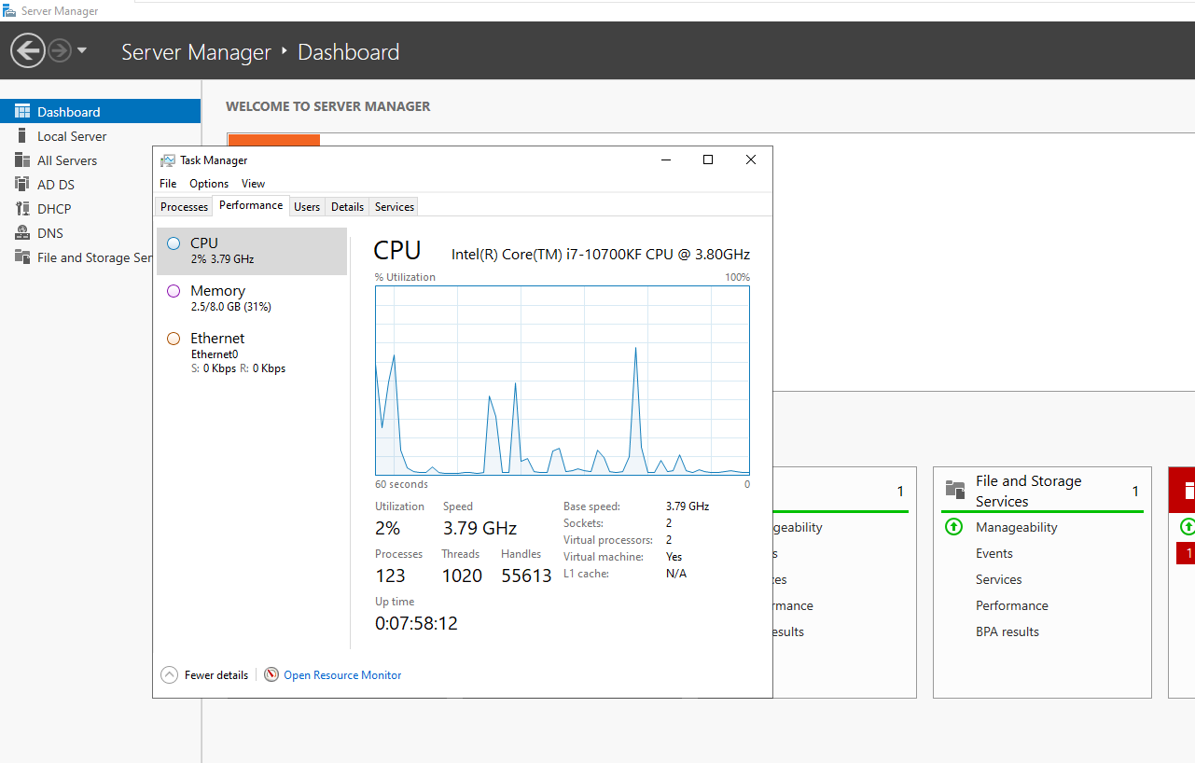

[Scenario - Tier 2 Infrastructure Troubleshooting] Finance Shared Folder Access Failure
A Finance employee reports that they can sign into the domain normally, but they can no longer access the Finance departmental shared folder. Other server functionality appears to be working.
Tier 2 Troubleshooting — Root Cause Identified
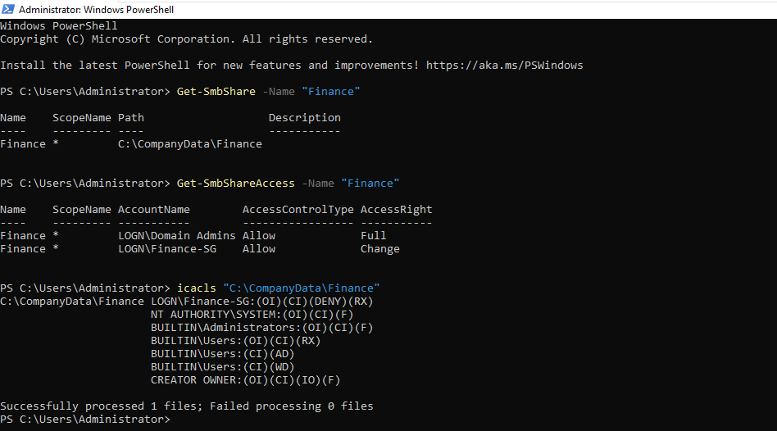
Tier 2 Troubleshooting — Service Restored
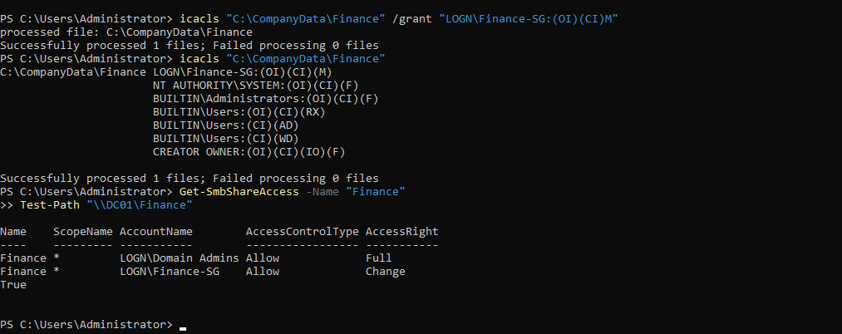
Shows the permissions have been restored for the finance department.

🎯 Outcome
Successfully configured, administered, secured, monitored, and validated a Windows Server 2022 domain environment representing a small business infrastructure. The project included Active Directory and DNS administration, DHCP services, departmental file storage, security group management, NTFS and SMB permissions, patch and firewall assessment, PowerShell administration, and server performance monitoring.
A simulated Tier 2 incident involving loss of access to the Finance departmental share was also investigated. Through systematic troubleshooting, the issue was isolated to an incorrect NTFS Deny permission assigned to the Finance security group. The permission configuration was corrected, appropriate access was restored, and the environment was successfully validated afterward.
The completed environment demonstrated that the domain controller, DNS, DHCP, Active Directory, SMB file services, security permissions, and core Windows Server services were functioning correctly at the conclusion of the project.

📚 What This Project Demonstrates to Employers
This project demonstrates practical experience performing common responsibilities expected of a Junior Systems Administrator / Systems Administrator, including:
- Windows Server Administration — Configuring and maintaining core Windows Server infrastructure and validating server health and service availability.
- Active Directory Administration — Working with organizational units, users, security groups, and group-based access to company resources.
- DNS & DHCP Administration — Managing essential network services responsible for name resolution and client IP configuration.
- File Server Administration — Creating centralized departmental storage and configuring SMB shares for network access.
- NTFS & Share Permissions — Applying group-based access controls and understanding the interaction between SMB share permissions and NTFS permissions.
- Security Administration — Reviewing Windows Update status, firewall configuration, and access controls as part of routine server security management.
- PowerShell Administration — Using PowerShell to inspect, configure, validate, and troubleshoot Windows Server components.
- Performance Monitoring — Reviewing CPU, memory, disk, network utilization, and other server health indicators.
- Tier 2 Troubleshooting — Investigating a reported departmental file-access incident by eliminating possible causes, identifying the root cause, implementing a corrective action, and validating service restoration.
- Infrastructure Validation — Performing post-configuration checks across Active Directory, DNS, DHCP, SMB, and Windows services to confirm that the environment remained operational.
- Technical Documentation — Documenting configurations, administrative procedures, troubleshooting evidence, screenshots, and final outcomes in a structured project format.

